**Coding Challenge-SQL**

**Name: Divya Sree Murali**

**Date : 08/11/2024**

**DataBase Details and data insertion**

**1.Creating Database**



**2.Creating customer_orders table**

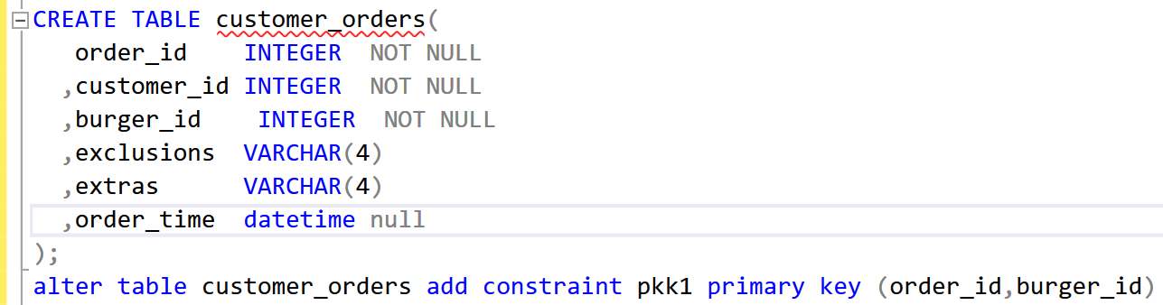

**3.Creating burger names table**

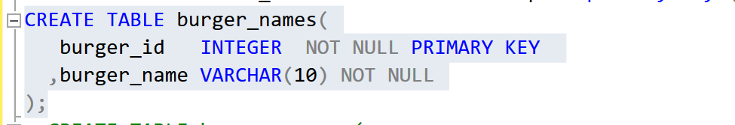

**4.Creating burger runner table**

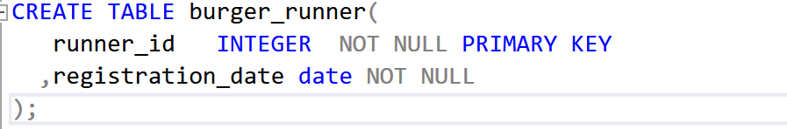

**5.Creating runner_order tables**

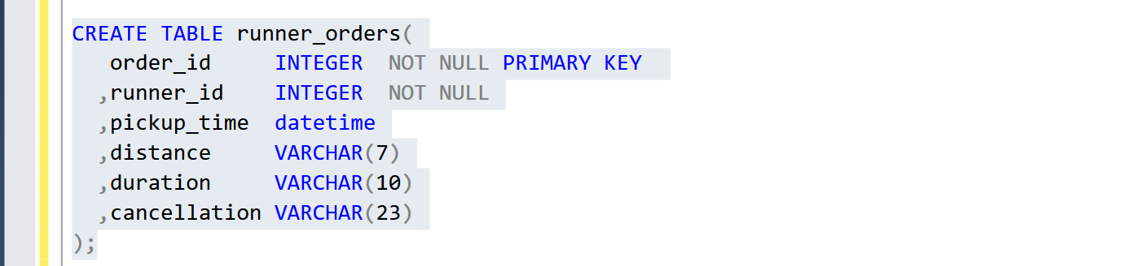

**6.Inserting data in customer_orders table**

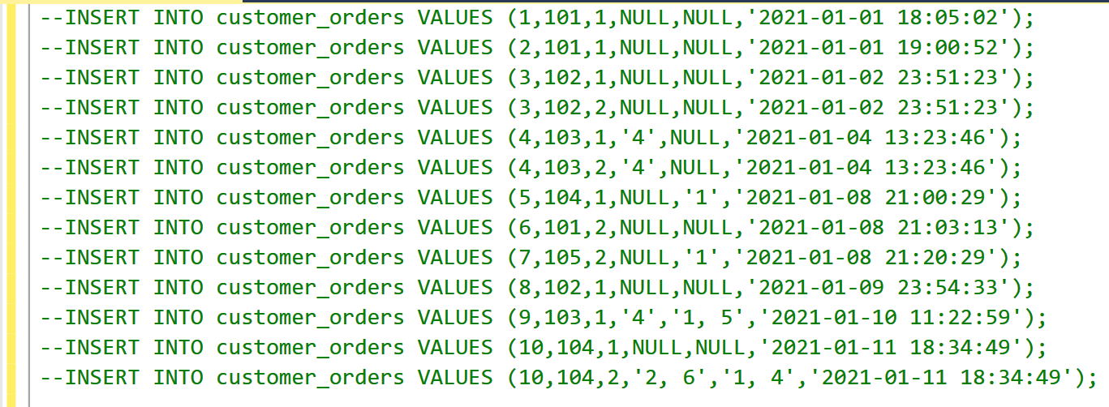

**7.Inserting datainto burger_names table**

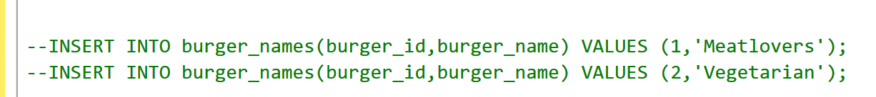

**8. Inserting data into burger_runner table**

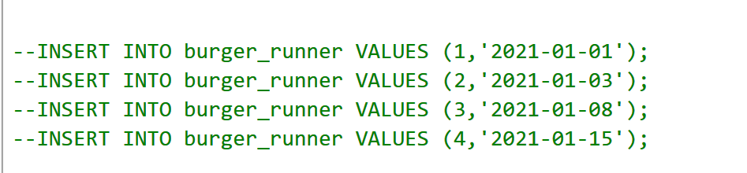

**9. Inserting data into runner_orders table**

